Suggested solutions to exercises, week 5.
Exercise 5.1

In an experiment with 4 sorts of blueberries, the fructification (the number of berries as a percentage of the number of flowers earlier in the season) was determined for 5 twigs on each of 6 bushes for every sort. The data are available in the file blueberry.txt—see also the Hierarchical Section 13.3 in eNote 13.

A1) Write down a natural model for the data
a) Investigate whether the 4 sorts have different fructification.
c) Test whether it is important to include bush as a random effect.
d) Interpret the differences between the sorts and make relevant post-hoc tests.
e) Draw conclusions.

Solution

A1)

A natural model (assuming a linear association between sort and fructification) could be

$$Y_{ijk}=μ+α_{i}+b_{j}+ϵ_{ijk}$$
where $Y_{ijk}$ is the fructification (%) for the i’th sort of the j’th bush on the k’th twig. $μ$ is the intercept, $α_{i}$ is the fixed effect of sort $i (i=1,…,4)$, $b_{i}$ is the random effect of bush $j (j=1,…,6)$. Note that we have 5 twigs for each bush, they are nested in the bushes and are the observational units where the measurements were taken. We further have that $ϵ_{ijk}\sim N(0,σ^{2})$, $b_{j}\sim N(0,σ_{b}^{2})$ and assume they are independent of each other.

We start by reading in the data, converting variables to factors and do a summary, to get an overview of the data. Lastly, we activate the lme4 package to get access to the lmer function.

blueberries<-read.csv("http://www2.compute.dtu.dk/courses/02429/Data/datafiles/blueberry.txt")
blueberries$sort<-as.factor(blueberries$sort)
blueberries$bush<-as.factor(blueberries$bush)
library(lmerTest)
summary(blueberries)

The summary gives the following output:

sort bush fruct
1:30 1 : 5 Min. : 0.00
2:30 2 : 5 1st Qu.: 44.00
3:30 3 : 5 Median : 67.00
4:30 4 : 5 Mean : 62.13
5 : 5 3rd Qu.: 83.00
6 : 5 Max. :100.00
(Other):90

Note that because we have converted the variables sort and bush to factors, the summary function simply counts the number of observations within each factor level. We see that sort has 30 observations for each of 4 levels, and that bush has 5 observations for each of 24 levels, as it should be from the description.

- To investigate whether the 4 sorts have different fructation, we perform a one-way analysis of variance, ignoring bush:

model1<-lm(fruct~sort,data=blueberries)
drop1(lm(fruct~sort,data=blueberries),test="F")
Single term deletions

Model:
fruct ~ sort
Df Sum of Sq RSS AIC F value Pr(>F)
<none> 67550 767.98
sort 3 11078 78628 780.20 6.3409 0.0005097 ***
---
Signif. codes: 0 ‘***’ 0.001 ‘**’ 0.01 ‘*’ 0.05 ‘.’ 0.1 ‘ ’ 1

From the output it is clear that the data supports that the 4 sorts have different fructation, as sort is strongly statistical significant. We can get an idea of which one that has the highest from the summary:

summary(model1)

Call:
lm(formula = fruct ~ sort, data = blueberries)

Residuals:
Min 1Q Median 3Q Max
-78.767 -14.083 5.167 18.183 43.167

Coefficients:
Estimate Std. Error t value Pr(>|t|)
(Intercept) 5.683e+01 4.406e+00 12.900 < 2e-16 ***
sort2 -9.503e-15 6.231e+00 0.000 1.000000
sort3 -7.333e-01 6.231e+00 -0.118 0.906512
sort4 2.193e+01 6.231e+00 3.520 0.000617 ***
---
Signif. codes: 0 ‘***’ 0.001 ‘**’ 0.01 ‘*’ 0.05 ‘.’ 0.1 ‘ ’ 1

Residual standard error: 24.13 on 116 degrees of freedom
Multiple R-squared: 0.1409, Adjusted R-squared: 0.1187
F-statistic: 6.341 on 3 and 116 DF, p-value: 0.0005097

From this output it is hinted that sort 4 has the highest fructation, while sort 2 and 3 cannot be distinguished from sort 1, relative to model1.

- To test whether it is important to include bush as a random effect, we invoke the lmer function:

model2<-lmer(fruct~sort+(1|bush),data=blueberries, REML = F)

# test of bush as random factor:

ranova(model2)

ANOVA-like table for random-effects: Single term deletions

Model:
fruct ~ sort + (1 | bush)
npar logLik AIC LRT Df Pr(>Chisq)
<none> 6 -550.26 1112.5
(1 | bush) 5 -550.26 1110.5 0 1 1

We get a warning message that there is a problem with the fit (have not included that in the program output) ; the reason is that the variance component is estimated to 0. From this observation and the test it is concluded that it is NOT important to include bush a random effects factor.

- For the differences between sorts, we resolve to the emmeans function for a start:

library(emmeans)
emmeans(model1, pairwise ~ sort)

$lsmeans
sort lsmean SE df lower.CL upper.CL
1 56.8 4.41 116 48.1 65.6
2 56.8 4.41 116 48.1 65.6
3 56.1 4.41 116 47.4 64.8
4 78.8 4.41 116 70.0 87.5

Confidence level used: 0.95

$contrasts
contrast estimate SE df t.ratio p.value
1 - 2 0.000 6.23 116 0.000 1.0000
1 - 3 0.733 6.23 116 0.118 0.9994
1 - 4 -21.933 6.23 116 -3.520 0.0034
2 - 3 0.733 6.23 116 0.118 0.9994
2 - 4 -21.933 6.23 116 -3.520 0.0034
3 - 4 -22.667 6.23 116 -3.638 0.0023

P value adjustment: tukey method for comparing a family of 4 estimates

The above output confirms the conclusion from the analysis in a), this time taking adjustments for multiple comparisons into account; the sorts group themselves in two groups; sort 4 has the highest fructation, while sort1-3 are indistinguishable.
We continue to illustrate this with the cld function from the multcomp package:

library(multcomp)
tuk <- glht(model1, linfct = mcp(sort = "Tukey"))
tuk.cld <- cld(tuk)
tuk.cld # Display the CLD
1 2 3 4
"a" "a" "a" "b"

The conclusion from this is clear and matches the above; Sort1-3 is in group "a" while sort 4 is in group "b", with no sort in between.
Lastly, we can illustrate the data by plotting boxplots with Tukey- corrected groupings on top:

old.par <- par(no.readonly=TRUE) # Save current graphics parameters
par(mai=c(1,1,1.25,1)) # Use sufficiently large upper margin
plot(tuk.cld, col=2:5)
par(old.par) # reset graphics parameters

The output is displayed below, and clearly shows the higher values of sort 4:

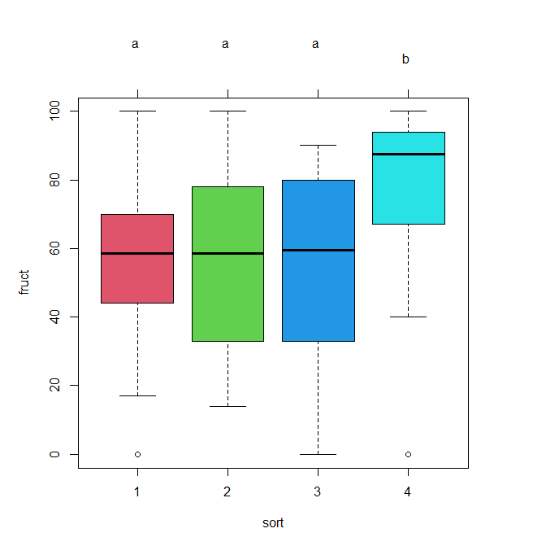

- To conclude on the analysis: The sorts group themselves in two groups; sort 4 has the highest fructation, while sort1-3 are indistinguishable wrt. fructation. bush has no statistically significant impact on the random structure of the model

